Last Name: _______ __________First Name: ____ ________ Student ID: ________

Last Name: ____________________First Name: ___________________ Student ID: ________________

TA (circle one): OSCAR CRISTINA JAVIER YAXI

ARE/ECN 115A | Spring 2017
Problem Set #4: RISK TAKING, INSURANCE MARKETS and IMPACT EVALUATION
(Due in class June 6, 2017)

Cristina, Oscar and Javier are maize farmers in the village of Girasol. They each have zero wealth (W=0), so their consumption is equal to the income they earn from their economic activity. Each of them must choose one (and only one) of the following three activities:

- Activity 1: Full time farming with hybrid maize: Hybrid maize has two important characteristics. First, it is labor intensive. To get the full benefit of hybrid maize, a farmer should work full time (7 days per week) on their farm. Second, hybrid maize is risky, because it is vulnerable to a combination of weather and pests. If a farmer works full time, she has a 50% probability of having a GOOD harvest and earning income of $280 and a 50% chance of having a BAD harvest and earning only $40.

- Activity 2: Full time farming with traditional maize. Traditional maize varieties are also labor intensive, however traditional maize is very well adapted to local weather conditions and thus has no risk. If a farmer works full time she will earns $140 with certainty.

- Activity 3: Part-time farming with hybrid maize: In this third activity, the farmer plants hybrid maize and works Monday through Thursday on her farm managing the hybrid maize, and she works Friday through Sunday as a construction worker in a nearby city. Since she is not able to work full-time on the farm, it is more likely that she suffers damages from pests or bad weather. Specifically, the probability of having a GOOD maize harvest and earning $280 drops to 25%, while the probability of having a BAD harvest and earning only $40 increases to 75%. The individual also earns $40 with certainty as a construction worker (i.e., she earns $40 in addition to her farm income under both a GOOD and a BAD harvest).

- What is the expected value of consumption for each activity (3 points)?

Activity 1:
Activity 2:
Activity 3:

- Cristina, Oscar and Javier view risk differently. This is reflected in the differences in their utility functions, which are listed below. Using those utility functions, compute the certainty equivalent (CE), the risk premium (RP) and expected utility (EU) associated with each of the three activities for each individual. Report your answers in Table 1 below (9 points).

- Cristina: $U\left(C\right)=2C$
- Oscar: $U\left(C\right)=40C-0.05C^{2}$
- Javier: $U\left(C\right)=0.1C^{2}$

Table 1. Certainty Equivalent, Risk Premium and Expected Utility for 3 Activities
 | Activity 1 | Activity 2 | Activity 3
EU Cristina
CE Cristina
RP Cristina
EU Oscar
CE Oscar
RP Oscar
EU Javier
CE Javier
RP Javier

- Which activity will be chosen by each individual (3 points)?
Cristina chooses:
Oscar chooses:
Javier chooses:

- Which type of risk preferences describe each individual (3 points)? (Risk Neutral, Risk Averse, or Risk Loving?)
Cristina is:
Oscar is:
Javier is:

- Assume that the three farmers start with the same level of wealth. In this environment would you expect wealth inequality to remain the same, increase or decrease over time? Explain your answer (2 points).

The government is interested in supporting higher adoption rates of hybrid maize and asks Yaxi, the CEO of “Take a Chen-ce on Me” Insurance Company to offer crop insurance to hybrid maize farmers. Yaxi conducts a market analysis and decides to offer conventional crop insurance contracts to full time hybrid maize farmers (Activity 1). She is not interested in offering insurance to part-time hybrid maize farmers. The contracts are straightforward. At the beginning of the season, farmers pay a premium of $120. At the end of the season, Yaxi pays farmers an indemnity payment of $240 if the farmer had a BAD harvest. If the farmer had a GOOD harvest, Yaxi doesn’t pay the farmer anything. For questions 6-10, assume that Yaxi has perfect information about the farmer’s activity choice. In other words, if a farmer buys her insurance, Yaxi is able to enforce a contract that requires the farmer to choose full-time hybrid maize farming.

- What is the expected value of Yaxi’s profit from an insurance contract? (Yaxi’s profit is just the premium she collects from the farmer minus the indemnity payment she makes to the farmer) (2 points).

- What is the expected value of consumption for an individual who chooses full-time hybrid maize farming (Activity 1) with Yaxi’s insurance contract (3 points)?

- What is the expected utility associated with full-time hybrid maize farming with an insurance contract for each individual (3 points)?

- Now assume that each individual can choose between the four available activities: Activity 1 with Insurance, Activity 1 without Insurance, Activity 2, and Activity 3. Which activity will each individual choose (3 points)?
- Cristina
- Oscar
- Javier

- In this environment of perfect information based insurance, would you expect wealth inequality to remain the same, increase or decrease over time? Explain your answer. Compare your answer here to your answer to question 5 (3 points).

Now let’s make a more realistic assumption about information. Assume that Yaxi can observe whether a farmer plants hybrid maize, but she cannot observe how much time the farmer spends working on her fields. This means that a farmer who plants hybrid maize may purchase the insurance contract and then choose to either farm full time or farm part time. An individual who plants traditional maize cannot purchase an insurance contract.

- Which activity will be chosen by each individual now (3 points)? (Activity 1 with Insurance, Activity 1 without Insurance, Activity 2, Activity 3 with Insurance, or Activity 3 without Insurance)

- What is Yaxi expected profit? Will she be willing to offer the insurance contract (3 points)? Why or why not? (what type of problem does Yaxi face)?

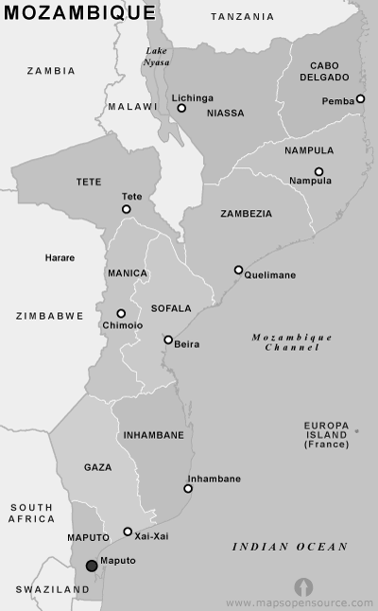

Maize holds a special place in the lives of many Mozambicans. However, it is concerning how low agricultural yields are for maize producers in the drought-prone Manica province where a lot of farmers practice subsistence farming. To address this problem, a project to increase agricultural production and raise farm productivity was designed by a group of UC Davis students. The project consisted of providing a new variety of a drought tolerant maize seed to a random sample of farmers located in Manica, which was specifically targeted because it is drought prone.

To evaluate the impact of this program, the students want to estimate the causal impact of the drought tolerant maize variety on agricultural yields denoted Y. First, they drew a random sample of 1,000 households that received the drought tolerant maize seed in Manica to serve as the treated group (D=1). At the same time, they drew another random sample of 1,000 households in the neighboring Sofala province who were not part of the program to serve as the control group (D=0). Via surveys, the students observed Y for both groups in tons per hectare.

The students used these measures of Y to estimate the Average Treatment Effect of the program by subtracting the average yield of the 1,000 households in Sofala from the average yield of the 1,000 households in Manica.

- At this point, the students reach out to you to ask for your guidance. Help the team understand Selection Bias by:

  - Providing an equation that defines Selection Bias using notation from the Potential Outcome Framework that we developed in class (4 points).

  - Writing a sentence that defines the two main terms in your equation (4 points).

  - Giving a careful and clear, but brief explanation of when selection bias would exist (i.e., when it would not be equal to zero) (4 points).

- Without any further information, do you expect selection bias in the students’ estimate of the Average Treatment Effect to be zero, negative or positive? Explain your answer (4 points).

For the rest of this question, use the table below. These average yields measured in tons of maize per hectare presume that you know all the counterfactual values of this outcome variable (e.g., you know $E[Y_{1i}|D_{i}=0]$, which is what the average yield for drought tolerant maize would have been for those who did not adopt drought tolerant maize)

 | Table 1
 | $$D_{i}=0$$ | $$D_{i}=1$$
$$E[Y_{0i}|D_{i}]$$ | 5.2 | 1.4
$$E[Y_{1i}|D_{i}]$$ | 5.5 | 2.5

- Which of the numbers in the table above can be measured by the researchers based on their survey data (2 points)?
- Based on this table, what is the students’ estimate of the Average Treatment Effect (4 points)?
- How large is the selection bias (provide a number) (4 points)?
- What is the true causal impact of the program on Y? (i.e., what is the true Average Treatment Effect?) (4 points)

